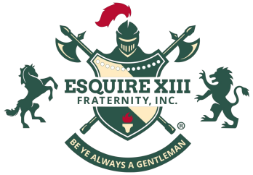

E S Q U I R E X I I I F R A T E R N I T Y, I N C.®

OUR HISTORICAL JOURNEY IN BRIEF

The Formative Years

The earliest Squires/Esquires (pictured) known to date at an Historically Black College or University were on the campus of what is now Winston-Salem State University beginning with its 1948/49 academic year.
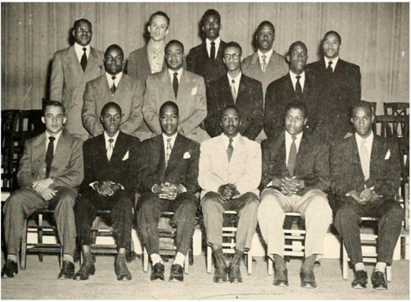
Similar organizations would began to flourish at other HBCUs like
North Carolina A&T State University in 1954 followed by Virginia
State University in 1955 then Voorhees University in 1956.

The 60’s and 70’s witnessed tremendous growth for us when an
untold number of loosely affiliated Esquire social clubs and service
fellowships were established including one at Fort Valley State
University - the first among us to incorporate its chapter on June 5,
1975.

Recognizing their commonality, various groups of Esquires gathered
Seated are Adviser Alvin Brown, President Rolland Lawrence, Vice President Alvis T. Daniels, Secretary James A. Turner, Assistant Secretary John H. Bennett, and Sergeant-At-Arms James A. Patterson. Standing are other club members.
in Atlanta, GA for the National “Umoja (Unity)” Convention in 1981
and decided to become a national organization under the banner
Esquire XIII Fraternity, Inc. - the name used by our bretheren at Fort
Valley State University.

Along the way, “Be Ye Always A Gentleman” became our motto and we committed ourselves to the pur-
pose of “enhancing the progress and prestige of the urban community and its universities.”
We continued to grow for a few more decades which included having a chapter at University of Mississippi
- a predominately white institution.
The Resurrection
We emerged from a brief hiatus by forming an Esquire XIII Fraternity Revitalization Board which began the arduous task of laying the foundation for our future success and longevity. On May 17th 2018 we, with new national bylaws to guide us, were incorporated as a national fraternity into perpetuity under the NonStock Corporation Act of the Commonwealth of Virginia.

On June 22nd 2019, a duly elected Grand Council began to usher in a new era of our beloved fraternity that honors our historical roots while incorporating the best practices of today. Through its efforts and those of subsequent grand councils, we have re-established our presence on the fraternal scene with four alumni and two collegiate chapters in the aftermath of COVID-19.

Just as the phoenix rose from the ashes, we are back on block and coming to a campus or community near you - stay tuned!
In Recognition and Gratitude

Today, we proudly recognize the Vogue XIII Sorority, Inc. as our sister organization and the Essences of Esquire as an affiliated women’s group. Through all of our joys and pains over the years, they have supported us every step of the way - thank you ladies.

